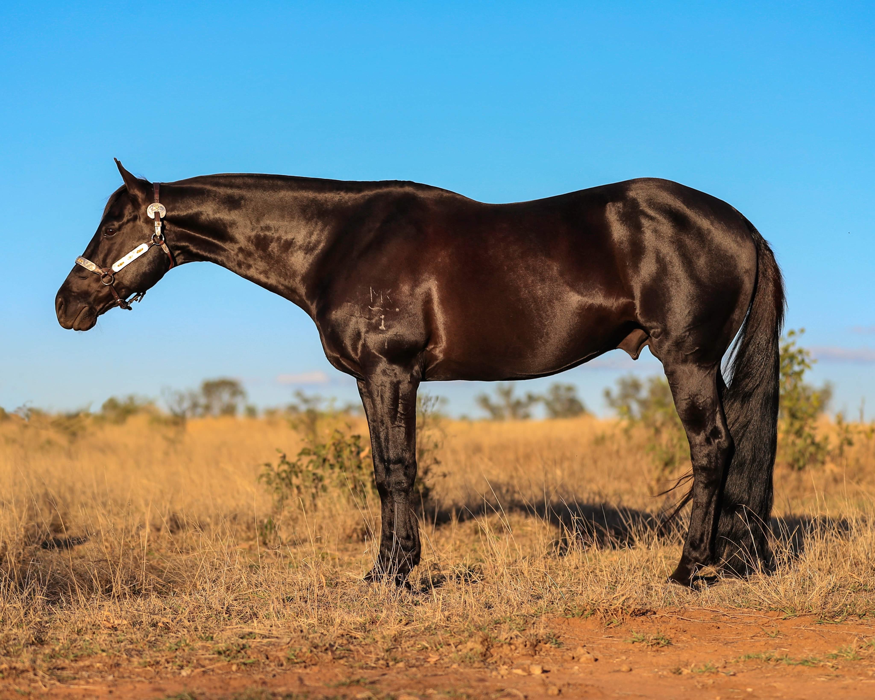
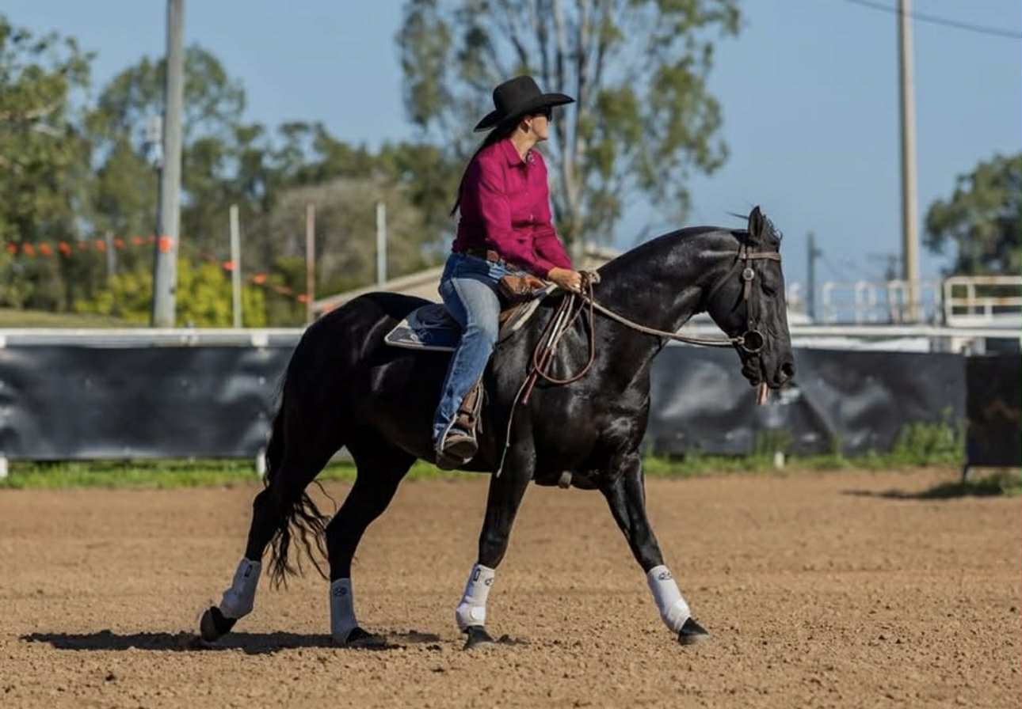
SILKY DYNASTY
ASHS: 186766
Application for Service and Breeding Contract for the 20__ season.
I / we __________________________________________________________________________________
Agree to breed the said mare_____________________________________________________________
Breed _____________________ Age __________________ Colour _______________________________
Rego # _____________________________________________ To SILKY DYNASTY (186766 )
One individual contract per mare being breed.
Mare Owner address _____________________________________________________________ Email Address: __________________________________________________________________
Mare Owner Mobile: _____________________________________________________________
Breeding Centre If chilled semen is required
Contact :_______________________________________________________________________
Mobile: ________________________________________________________________________ Address for Con note: ____________________________________________________________
Frozen and chilled / shipped semen is available. 48 Hours notice is required for chilled collections. Collection, shipping and vet fees will be at the mare owners expense.
The Stallion for this service will stand for Live Cover Spring Field Lane, Tarcutta NSW 2650.
Contact: Sally Moore: 0428 800 655 – Email – sallymoore31@icloud.com
Confirmation of approval required prior to live cover.
Service Fees for this contracted Breeding Season, please tick which applies to you and insert the amount below.
☐ $1600.00 for first mare ☐ $1100.00 for 2nd and subsequent mares the same season
☐The Total Stallion Service Fee is $______________ including GST.
☐ FULL SERVICE FEE AMOUNT MUST BE PAID ON SIGNING THIS CONTRACT
Account Details: Sally J Moore BSB: 633 000 ACC: 158 055 582 REF: Name
- The mare owner warrants that to their knowledge the mare being breed to SILKY DYNASTY and arriving at Spring Field Lane, TARCUTTA, NSW 2650, will be in good health and has NOT been in contact with CONTAGIOUS EQUINE METRITIS, STRANGLES OR ANY OTHER INFECTIOUS DISEASES. A vet pre breeding scan is required before live cover. Mares must be dewormed and up to date with tetanus / strangles vaccinations before arriving at our facility.
- If shipped / chilled semen is needed, 48 hours notice is required. All veterinary expenses including scans and any treatment the mare requires while at the vet centre or our facility will be at the mare owners expense. It is agreed that Sally Moore shall not be responsible for any injury to the Mare or her progeny or loss incurred by the Mare Owner however caused. Nor shall she be responsible for any disease, accident, sickness or death to the Mare or foal.
- Agistment for dry mares $25 per day, wet mares $35 per day. If mare requires private paddock agistment with hay and hard feed twice daily $40 per day. Agistment will be charged from the day of mares arrival until the date of departure. The breeding Service Fee will be paid in full on return of breeding contract, agistment and veterinary expenses will be paid in FULL on mare departing our facilities.
- A Live Foal Guarantee is offered with this service fee if the foal dies within 48 hours of foaling, or if stillborn, in both cases a report certified by a practicing Veterinary Surgeon is required within 10 days of the date of the foal’s death. It is then agreed that the Owner may return the Mare for breed- ing for the following breeding season and no additional Service fee will be charged, for one season only, other associated charges will still apply.
- ASHS Breeding Certificates will be issued upon request, when a live foal is born.
- Mare Owner ______________________________________________________________
Address __________________________________________________________________
Signed ______________________________________ Date _________________

